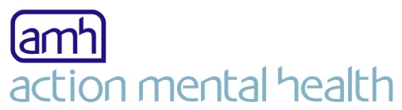
Sponsorship Form
Action Mental Health changes the lives of those living with mental ill-health and promotes resilience and well-being to future generations.
I am taking part in: ........................................................................On: ....................................................
Name: ......................................................................................................................................................
Address: ...................................................................................................................................................
Email address: ……………………………………………………………………………………………………………………………………….

Give more for free – Gift Aid your donation! For every £1.00 you donate, Action Mental Health can claim an additional 25p more – By ticking the box headed ‘Gift Aid’ below you confirm that you are a UK Income or Capital Gains taxpayer, have read this statement and want Action Mental Health to reclaim tax on your donation, given the date shown, you understand that if you pay less Income Tax / or Capital Gains in the current tax year than the amount of Gift Aid claimed on all of your donations it is your responsibility to pay any difference and you understand that the charity will reclaim 25p of tax on every £1 that you have given.

Remember: You must provide your full name, home address, postcode and tick the gift aid box below for Action Mental Health to claim tax back on your donation.

Full name | Home Address | Postcode | Amount | Gift Aid | Date | Amount Received
For example | 1 Any Street Anywhere | BT00 1AC | £10.00 |  | 1/1/14 | £10.00
 |  |  |  | Total:
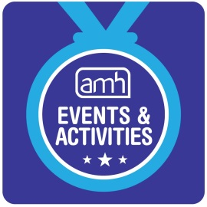

Did you know...?
- One in five adults in Northern Ireland will show signs of a mental illness
- When matched to 17 other countries, NI had the 2nd highest rates of mental ill-health
- Prevalence of mental illness in Northern Ireland is 25% higher than in England

Since 1963, Action Mental Health have been supporting recovery, building resilience, raising awareness and promoting positive mental health.
AMH Mission
To make a positive difference in people’s mental health
AMH Vision
A society which actively values and promotes good mental health

website: www.amh.org.uk E-mail: events@amh.org.uk

Please send your completed sponsorship form to:
Callum Clark
AMH Central Office
27 Jubilee Road
Newtownards
BT23 4YH
(Please make cheques payable to Action Mental Health)

Registered charity recognised by the Inland Revenue Irv Ref No. XN / 47959. Registered with The Charity Commission for Northern Ireland NIC100753
Registered in Northern Ireland Company No NI 5568. Registered office: Central Office 27 Jubilee Road Newtownards Co Down BT23 4YH Tel: +44 (0)28 9182 8494

