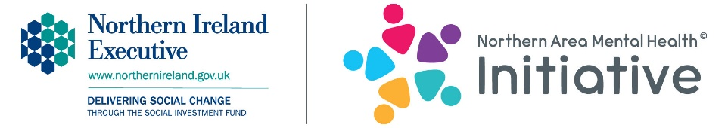

Northern Area Mental Health Initiative
Organisation & Community Booking Form
Please enter X in the box/es below to indicate which workshops you are interested in.
Workshops available | Action Mental Health | Nexus NI
Staff | Increase your skills, knowledge and awareness on mental health, to enable you to identify and support 8 – 25 year olds presenting with issues affecting mental health and emotional well-being. 2.5 hours required. | Increase your knowledge of the risks of sexual exploitation, abuse and grooming, as well as online safety.  2.5 hours required.
Parents | Increase your skills, knowledge and awareness on mental health, to enable you to identify and support 8 – 25 year olds presenting with issues affecting mental health and emotional well-being. 2.5 hours required. | Increase your knowledge of the risks of sexual exploitation, abuse and grooming, as well as online safety.  2.5 hours required.
Young people aged 11 – 16 years | Increase your skills, knowledge and awareness of the signs and symptoms of mental ill-health as well as tips on self-help/self-care.  Allow 1.5 hours for workshop.  Increase your skills, knowledge and  awareness of how to prevent exam  stress/stress.  Allow 1.5 hours for workshop.  Increase your confidence and build  self-esteem.  Allow 1.5 hours for workshop.  Increase your knowledge and awareness of body image messages.  Allow 1.5 hours for workshop.  Increase your knowledge, awareness  and skills required to deal with bullying.  Allow 1.5 hours for workshop. | Internet safety, sexual abuse and exploitation education – increase knowledge of the risks of sexual exploitation, abuse and grooming, as well as online safety.  Allow 1.5 hours for workshop.
Young people aged 16 – 25 years | Increase your skills, knowledge and awareness of the signs and symptoms of mental ill-health as well as tips on self-help/self-care.  Allow 1.5 hours for workshop.  Increase your skills, knowledge and  awareness of how to prevent exam  stress/stress.  Allow 1.5 hours for workshop.  Increase your confidence and build  self-esteem.  Allow 1.5 hours for workshop.  Increase your knowledge and awareness of body image messages.  Allow 1.5 hours for workshop.  Increase your knowledge, awareness  and skills required to deal with bullying.  Allow 1.5 hours for workshop. | Internet safety, sexual abuse and exploitation education – increase knowledge of the risks of sexual exploitation, abuse and grooming, as well as online safety.  Allow 1.5 hours for workshop.
About your group and community
Venue resources | Does your venue have the following available?  Projector Speakers  Projector screen Internet access
Additional information | Please add any mental health issues or concerns within the group or local community that we need to be aware of and sensitive to:
Access to services | Are you aware of any local support services in your area that we could promote to the young people/staff?
Specific learning needs of group
Please highlight the SOAreas that you have young people attending from | Coleraine Ballysally 1 Central CrossGlebe Churchland Newtownabbey Valley 2 Dunanney Monkstown 1 Coole Mossley_ Carnmoney_ Antrim Farranshane Larne Ballyloran Craigy Hill Antiville Carrickfergus Northland Sunnylands Ballymena Ballee Ballykeel Moat
Key contact name
Job title/role

Organisation
name
Organisation address and postcode

Workshop venue address (if different from above)
Telephone number
Email
Requested date of workshop
Perferred time of workshop
Expected numbers
Social media | To help promote The Initiative we may mention your community group/organisation as a beneficiary of the workshops on websites, social media, in the press, newsletters etc. and include photographs. If young people are under 18 we will not identify them.  Do you give your consent? YES NO  Please provide your handle for: Facebook ____________ Twitter ____________

Please note: a minimum of six people is required for each workshop to run.
24 hours notice is required for cancellation.
Please return this form to northernareamhi@amh.org.uk

