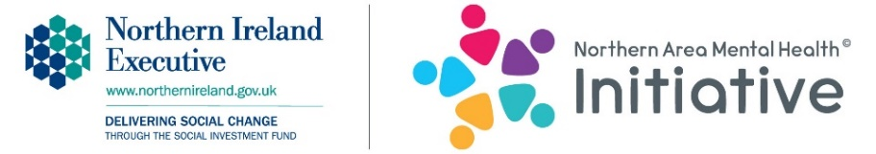

Northern Area Mental Health Initiative
Key Contact (parents, youth leaders, carers, professionals) Booking Form
Please enter X in the box/es below to indicate which workshops you are interested in.
Workshops available | Action Mental Health | Nexus NI
Key contacts - Professionals | Increase your skills, knowledge and awareness of the Northern Area Mental Health Initiative and how it aims to complement, and be an additional service that you can recommend and promote to young people and parents.  Learn about the partners involved, the Initiative’s approach, the main objectives, workshops that can be accessed and areas covered.  1 hour required.
Key contacts –  Professionals  Teachers  Parents  Youth leaders Carers  Coaches  Peer advocates etc | Improve your, knowledge and awareness of mental health, to enable you to identify and support 8 – 25 year olds presenting with issues affecting mental health and emotional well-being.  Increase your skills and be empowered and inspired to develop resilient cultures/environments that will open conversations and address barriers impacting on young people accessing appropriate support, such as attitudes to mental health, poor coping skills, poor knowledge of available services and myths about professional help.  2.5 hours required. | Increase your knowledge of the risks of sexual exploitation, abuse and grooming, as well as online safety.  2.5 hours required.
Contact name
Job title/role

Organisation

Telephone number
Email

Please return this form to northernareamhi@amh.org.uk and a Project Worker will be in touch.
