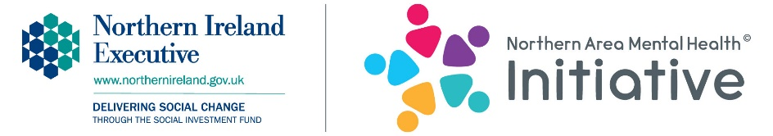
Northern Area Mental Health Initiative
Primary School Booking Form
Please enter X in the box/es below to indicate which workshops you are interested in.
Workshops available | Action Mental Health | Nexus NI
All staff | Mental Health Awareness/Resilience training to increase your skills, knowledge and awareness, to enable you to identify and support 8 – 25 year olds presenting with issues affecting mental health and emotional well-being. | Increase your knowledge of the risks of sexual exploitation, abuse and grooming, as well as online safety.
Teachers | Mental Health Awareness/Resilience training to increase your skills, knowledge and awareness, to enable you to identify and support 8 – 25 year olds presenting with issues affecting mental health and emotional well-being. | Increase your knowledge of the risks of sexual exploitation, abuse and grooming, as well as online safety.
Parents | Mental Health Awareness/Resilience training to increase your skills, knowledge and awareness, to enable you to identify and support 8 – 25 year olds presenting with issues affecting mental health and emotional well-being. | Increase your knowledge of the risks of sexual exploitation, abuse and grooming, as well as online safety.
Primary 5 | Mental health and emotional well-being workshop promoting and raising awareness of the signs and symptoms of mental ill-health, self-help/self-care.
Primary 6 | Mental health and emotional well-being workshop promoting and raising awareness of the signs and symptoms of mental ill-health, self-help/self-care.
Primary 7 | Mental health and emotional well-being workshop with a focus on transition to post primary, promoting and raising awareness of the signs and symptoms of mental ill-health, self-help/self-care.

Key contact name
Job title/role
School
Telephone number
Email
Please highlight the SOAreas that you have pupils from | Coleraine Ballysally 1 Central CrossGlebe Churchland Newtownabbey Valley 2 Dunanney Monkstown 1 Coole Mossley_ Carnmoney_ Antrim Farranshane Larne Ballyloran Craigy Hill Antiville Carrickfergus Northland Sunnylands Ballymena Ballee Ballykeel Moat
To help promote The Initiative we may mention your school as a beneficiary of the workshops on websites, social media, in the press, newsletters etc and include photographs. If children are under 18 we will not identify them.

Do you give your consent? YES NO

Please return this form to northernareamhi@amh.org.uk

