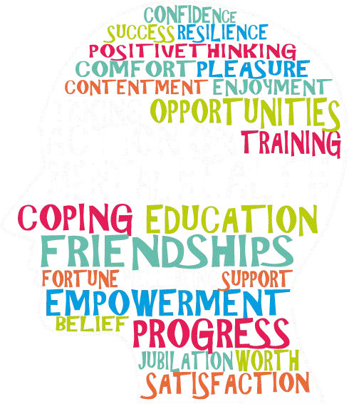

Manifesto for the Northern Ireland Assembly Election 2022

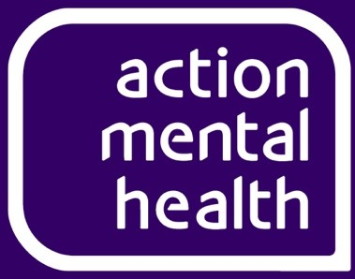

ESF/Disability Services
Briefing Paper - April 2022

GENERAL

This Briefing Paper highlights that there is no policy response from NI to the impending loss of ESF support. There is only a hope that the UK Shared Prosperity Fund, run from Westminster, will deliver the support required. It is becoming clearer it will not and certainly not the gap in support that will be left for the 22 Disability providers who support people furthest from the workplace. Action is required urgently to support thousands of the most vulnerable people in our communities whose support will start to end within 6 months.

Action Mental Health (AMH) is one of NI’s leading disability and mental health charities with 242 staff working from 14 sites and in the community to deliver recovery, resilience, and counselling services to over 24,500 clients per year.

CURRENT ESF PROVISION

For over two decades, the ESF Programme, funded by the EU, has been a vital source of funding to the sector across NI. The strategic aim of the programme is to combat poverty and enhance social inclusion by reducing economic inactivity and to increase the skill bases of those currently in and future potential participants in the workforce. Often people who benefit from these programmes are the furthest from the labour market and from marginalised and disadvantaged backgrounds. There are many other outcomes as well, such as improvement in wellbeing and an increase in coping skills and resilience which gives people the confidence to lead independent lives.

ESF has helped over 76,000 people since 2018 with over 11,000 participants moving into employment and another 11,000 into further education and training. Administered by DfE, the ESF budget is currently £177m for 69 projects of which £60.7m is for 22 disability projects which form a key pillar to the NI Executive’s response to barriers to employment for employees with a disability and mental health recovery services.

In terms of disability in NI, there is no current Disability Strategy in place although a new strategy is being developed, along with other DfC Social Inclusion strategies; there is no indication when the strategy might be agreed and implemented, it’s going to be too late anyway. There was a Disability Employment Strategy which ran from 2015-20, however, the replacement Strategy is still at development stage and it could be this Autumn before it even goes out to consultation. All this ongoing work it is too late, its under-developed and may not meet the needs of these vulnerable people anyway, answers to post ESF

support are required in a few months. Many of these clients are those who have had the hardest time during Covid, facing isolation and financial hardship that the rest of us may not have had to face.

AMH PROVISION

AMH has been operating ESF disability services since 1997 and c.100 staff work across 10 locations. Under the current ESF programme (extended to March 2023) AMH supports 1,715 recovery clients with diagnosed Mental Health issues to transition back into community or employment. These services provide direct referral routes for statutory sector partners within the local health trusts.
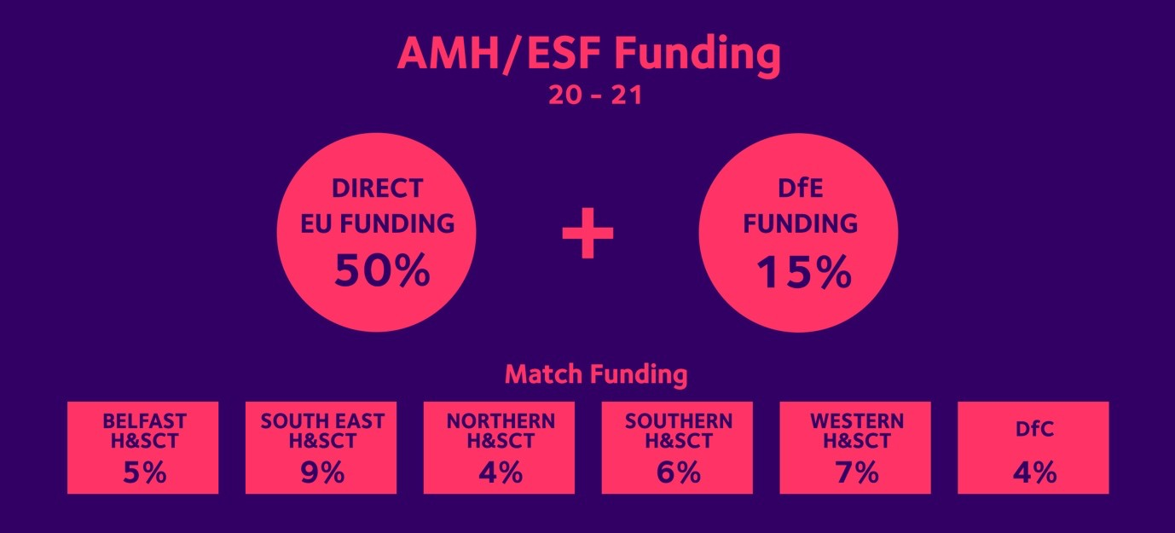

54% of AMH participants stay in employment for over 6 months
16% go into further training after participating

NI RESPONSE

Much of the difficulty for NI is that any response to post ESF support requires cross departmental working. Current support delivers jointly-funded outcomes across DfE, DoH, DoJ, DfC but no one Department is currently taking responsibility. The DoF is also aware of the issue and involved but there is no sense that anyone is prepared to provide clear leadership.
NICVA, NIUSE, ARC and providers have engaged with politicians and officials and will continue to do so, but in 6 months’ time vulnerable clients will need to be reassured about where they go or who will support them. Across all providers there are 39,792 clients so answers are required rapidly.
These are highly vulnerable people and they, and their carers/families, need to be prepared for the future.

Alongside the impact of Covid there is concern that these thousands of clients are now facing a Cost of Living crisis. Regardless of the Chancellor’s Spring Statement support its expected that fuel bills will rise dramatically with 10m in fuel poverty across UK, absolute poverty increasing and over-subscribed foodbanks and debt crisis agencies unable to cope or provide any further tools to support people.

OUR ASKS
- A Transition Period - an interim programme, ideally for 3 years to 2026 while a new programme is designed. Covid and political instability have been distractions, but this will ensure the most vulnerable are not deserted.

- Clarity on how support through a successor programme will be managed and delivered.

This approach requires strong leadership and it is requested that this approach is endorsed and supported to address these important issues which impact our most vulnerable people.

CONTACT DETAILS
Should you have any questions or require further information on this briefing please contact:
Jonathan Smyth, Head of Communications & Fundraising T: 028 9182 8494
E: jsmyth@amh.org.uk

